# Intraspecific germination variability in water-limited alpine/High Mediterranean Mountains environments.

Abstract

## 1. Introduction

Mesoscale heterogeneity of alpine landscape; microclimatic conditions; species adaptations (similar to move along intro)

Snowmelt gradients and summer drought effects

Snow depth and snowmelt patterns strongly influence surface-level temperature, moisture and light, three key abiotic factors determining plant growth and reproduction in the corresponding communities (Winkler et al. 2018; Körner 2021).

Regeneration niche and Mediterranean germination syndrome

The majority of the empirical tests of niche theory focus on adults ignoring the importantseedregeneration niche (Briceño et al 2015, Larson and Funk 2016).

Temperature and water, two major environmental drivers of the physiological process ofseedgermination (Bewley et al. 2013).

As these two environmental factors are essential for germination, the integration of heat accumulation units and soil water availability as hydrothermal time is considered a useful approach to describe germination progression over time ofseedlots or populations under field conditions (Allen et al. 2000; Bradford 2002; Bewley et al. 2013). The use of hydro thermal time is based on the premise thatseedgermination rate is related to temperature (T) and water potential (.) around optimum conditions that are bound by lower and upper thresholds (Allen et al. 2000; Bradford 2002). Therefore, total germination and germination rate will occur as long as both conditions are met: 1) temperature is within the thresholds and 2) water potential is above the minimum. The longer the time these two conditions are met (i.e., hydrothermal time accumulation), the greater the germination.

Sensitivity to drought conditions depends on multiple factors and may be higher during germination and establishment (Fischer & Turner 1978).

Components of the life history of plants, such asseedsize, are significantly associated with plant height, growth form and dispersal mode, and can also influence recruitment patterns (Leishman & Westoby 1994).seedsize has a high impact on capacity and time of germination, establishment and survival of dlings during early stages of the life cycle, when plants are more susceptible (Baskin & Baskin 1998). In general, average germination time tends to be greater for larger-sized seeds(Norden et al. 2009), while small seedsabsorb water faster than large seedsbecause of their larger surface-area-to-mass ratio (Kikuzawa &Koyoma 1999). For example, Kidson & Westoby (2000) argued that larger seedsare able to germinate better under drought, while Merino-Martín et al. (2017) reported that most light seedshad higher germination and emergence under dry conditions than heavier ds. The authors recognize that more studies are required in order to understand whether the role ofseedsize in germination response under drought is general or species-specific (Gelviz-Gelvez, 2020)

Although germination response to climatic factors has been investigated for alpine/subalpine species at population and community levels (Cao et al., 2018; Cavieres & Arroyo, 2000; Giménez-Benavides, Escudero, & Pérez-García, 2005; Liu et al., 2011, 2018;Shimono & Kudo, 2005; Wagner & Simons, 2009).

Drought effects on germination are more commonly studied in water-limited systems (e.g. Cochrane et al., 2014). Other germination in alpine systems often focus on the impacts of warming (Fernández-Pascual 2021, Hoyle 2013, Mondoni 2012) BUT what about alpine + water limited???

In alpine regions, much of the increased precipitation falls as snow. But as increased temperature leads to earlier snowmelt, increased evapotranspiration, and increased run-off, this can paradoxically result in higher risks of early summer soil moisture deficit in the alpine in the future (Hanssen- Baeuer et al., 2017)

At the global scale, environments with stable climate are expected to select for and be dominated by taxa that produce relatively large, fast-germinating ds, while relatively small seedsshould be adaptive to and predominate in seasonal habitats (Rubio de Casas et al., 2017). Species with small seedshave high temporal variation in germination that spreads the risk of extinction, and large seedsproduce large dlings that perform better than small ones under stressful conditions (Kitajima & Fenner, 2000; Pake & Venable, 1996).

However, species vary considerably in response ofseedgermination to drought stress (Kos & Poschlod, 2008).

Water stress /PEG

Plants from drier habitats tend to produce larger seedsin order to provide more resources for handling drought stress during germination (Wellsteins et al., 2013).

Reduced water availability can result in delayed germination (Cochrane et al 2015, Vázquez-Ramírez and Venn 2021)

In alpine lichen heaths, communities occurring at the snow-poor end of the gradient, we expected seedsto be able to germinate at comparatively low soil water contents, due to the low water supply from the melting snowpack and the fast-drying skeletal soils (Onipchenko2004).

Low and spread out germination (Gya 2023) could be an indication of bet-hedging, a strategy well known for germination in habitats with high variability in climate (Evans and Dennehy, 2005). Bet hedging has been found to be a strategy that yields advantages during drought events (Evans and Dennehy, 2005, Lampei et al 2017).

Drought events can vary in duration, magnitude, and severity [19]. It is important to explore the stage specific drought adaptations of important plant species. In particular, variation inseedgermination and dormancy in response to water deficit requires scrutiny (Bernau 2020). Drought resistance can be separated into several different strategies: dehydration avoidance,

dehydration tolerance, and dehydration escape [23]. For instance, maintaining seedsin

an un-germinated state during dry periods can allow them to escape dehydration, although

d dormancy has many other adaptive dimensions (as reviewed in [24]).

A common methodology in most studies using hydrothermal time is the use of polyethylene glycol (PEG) to generate different water potentials as described by Michel (1983). PEG solutions have the advantages of maintaining relatively steady osmotic potentials equivalent to the desired water potentials as well as the simplicity with which a wide range of water potentials can be generated to determine germination thresholds (Bewley et al. 2013).

Requirements determined with PEG solutions might not be appropriate to describe fieldseedgermination (Camacho 2021), so direct soil water potential measurements might be needed (Bullied et al. 2012). Soil textural properties could influence the response of theseedto water potential, and this could result in different germination behaviours (Camacho 2021). Comparing osmotic and matrix potentials using PEG solutions as well as soil matrices with different soil particle sizes, Hadas (1977) determined that water potential is important forseedgermination as long as soil moisture content is not limiting, but as soon as water content or water diffusivity decrease, soil physical properties influencing water supply to theseedwill play a more important role. The use of PEG solutions is a practical way to determine relative differences in water use between species, genotypes, orseedlots, but it is not an adequate system to determine accurate germination responses to water availability, which ms to be the aim of many studies. Potential for multiple species as a function of soil physical properties

Soil hydraulic conductivity thresholds identified in the present study, represent a useful parameter to be included inseedgermination and dling emergence studies, because it provides a clear limit to germination (Camacho 2021).

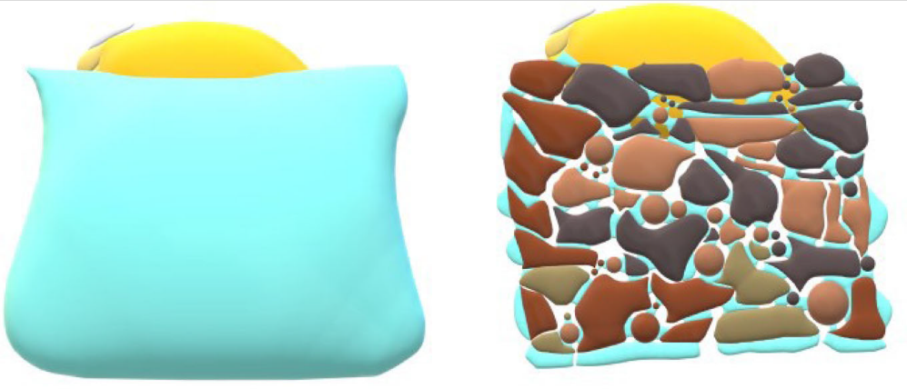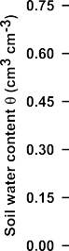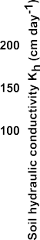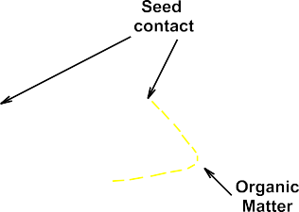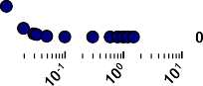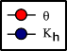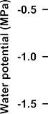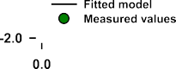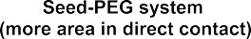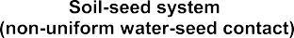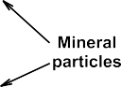

Fig 6 from Camacho 2021.

Intraspecific germination variability to water stress

Variation inseedgermination of a species under different environmental conditions can increase long-term reproduction of plant populations by temporally spreading risk and thus maximizing their fitness (Philippi & Seger, 1989; Simons, 2011; Venable, 2007).

Intraspecific variation in germination responses to abiotic gradients has received less attention (Gya et al., 2023).

Populations within species may vary in their germination responses along environmental variables as a consequence of local adaptations (Grassein et al., 2014; Kawecki & Ebert, 2004), for instance, by optimizing germination timing and rate to population-specific environmental conditions (Baskin & Baskin, 2014; Giménez-Benavides et al., 2007; Meineri et al., 2013; Satyanti et al., 2019). The selective pressures operating on such local adaptations may generally be expected to be high in alpine ecosystems due to harsh environmental conditions, topographically complex landscapes, and high microclimate variability (Scherrer & Körner, 2011). This environmental variability within the alpine habitats leads to high but spatiotemporally variable seedling mortality rates (Graae et al., 2018; Scherrer & Körner, 2011), which further suggests selection for locally adapted seed regeneration responses in alpine species (Giménez-Benavides et al., 2007; Kim & Donohue, 2013; Mondoni et al., 2009). While such local adaptions may increase the total range of conditions under which the species as a whole can survive, each locally adapted population tolerates a narrower range of conditions and can be vulnerable to climate change, especially if dispersal is low (Atkins & Travis, 2010; Valladares et al., 2014). Local adaptations could therefore confer a higher vulnerability to climate change of each population than inferred from the species-wide geographic distribution and climatic range (Atkins & Travis, 2010; Diamond & Martin, 2020; Peterson et al., 2018, 2019).

Seed collection of 1 specialist/strict alpine species, *D. langeanus*, from Mediterranean high mountain grasslands. Seed collection the 7th-8th of August 2023, from 18 different collection sites or subpopulations. Collections sites where we previously buried iButtons for 11 months (from 12/7/2021 to 29/05/2022) and we have temperatures registered every four hours. Additionally, we have hourly temperature and water potential data from 7 subpopulations (A00, B00, B07, C00, C18, D00, D12).

Fresh seeds germination trial: (A00, B00, B03, B07, B17, B19, C00, C06, C19, D00, D19, D12). Seeds from 12 subpopulations were subjected to 7 water stress treatments (h2O, -0.2, -0.4, -0.6, -0.8, -1, -1.2 MPa, following standard typical with PEG 6000). four Petri dish 90mm diameter with 25 seeds for each WP treatment (100 seeds x treatment). Seeds sowed in two layers of germination paper. Added 5ml of PEG solutions and sealed Petri dishes with parafilm to avoid evaporation of the solution.

After-ripening germination trial: (A00, A02, A11, B03, B19, C00, C18, C19, C20, D00, D11, D19) seeds from 12 subpopulations were subjected to 7 water stress treatments (h2O, -0.2, -0.4, -0.6, -0.8, -1, -1.2 MPa, following standard typical with PEG 6000). four Petri dish 90mm diameter with 25 seeds for each WP treatment (100 seeds x treatment, number were adapted in subpopulations with lower seeds). Seeds sowed in two layers of germination paper. Added 5ml of PEG solutions and sealed Petri dishes with parafilm to avoid evaporation of the solution.

6 populations were subjected to both fresh and after-ripening sowing (A00, B03, C00, C19, D00, D19)

Last paragraph introduction

Here we study intraspecific germination in adaptation to water stress in high Mediterranean mountains dry grasslands. We focus in to understudied topics (1) germination in water-limited High Mediterranean Mountains/alpine environments and (2) intraspecific variability of germination responses to water stress at the microscale level. Our specific research questions are: (1) Will seeds from warmer (i.e., drier) subpopulations germinate better under higher water stress levels? Thus, is there intraspecific local adaptation to the realized niche from adult plants? To calculate hydrotime models we need non-dormant ds, however, some oromediterraneous species are known to have some level of dormancy alleviated by after-ripening. No previous studies (to our knowledge) addressed this question in Dianthus langeanus, thus a second questions arises that needs to be answered first (2) Does the seeds' ripening stage (fresh vs. after ripened seeds) modify their response to water stress? We hypothesize that we will not find germination differences between ripening stages (results: fresh seeds have higher variability of germination responses and germinate worse) and that seeds from warmer/drier subpopulations will germinate better and faster at higher levels of water stress (results YES). To test our hypothesis we conducted a growth chamber experiment to investigate subpopulation-level intraspecific variation of germination to water stress. The results can help us understand how germination will respond to future climate change scenarios where precipitation is predicted to become more unpredictable and concentrate in intense episodes.

## 2. Methods

### 2.1. Study system

This study focuses on *Dianthus langeanus* Wilk. (Caryophyllaceae), a wild carnation endemic to the mountain systems of the northwestern Iberian Peninsula (Fig 1A). *D. langeanus* (Wilk Caryophyllaceae) mainly lives in open dry grasslands on acid soils (Fig 1B), where it can be locally abundant. Previous experiments indicate that this species has high seed production (Fig 1C) and high and fast germination responses at 20ºC (move along paper). We studied wild populations of *D. langeanus* in the northern limit of its distribution, in the Valles de Omaña and Luna Biosphere Reserve, in the southern ranges of the Cantabrian Mountains (Fig 1A, red square). The Cantabrian Mountains run E-W in northern Spain along 480 km in parallel to the Cantabrian Sea … . This mountain hub encloses summits above 2,500 m a.s.l and the treeline climbs up to 1600m a.s.l (ref TFM Jorge). It is considered a transitional biogeographical hub between the Eurosiberian and Mediterranean regions (Jiménez-Alfaro et al. 2021), influenced by Mediterranean climate on the southern slopes and temperate climate on the northern slopes.

### 2.2. Field sites

We established a systematic sampling across four summits above 2000 m a.s.l. (Fig 2 upper panel) inside the distribution area of *D. langeanus* and was highly abundant. In each summit we established a central representative plot (3m radius) where we did a floristic inventory and buried, at 5 cm deep, a Microlog SP3 datalogger, with hourly records of soil temperature and water potential (datalogger MicroLog SP3, EMS Brno, Czech Republic; accuracy in temperature measurements: +/- 0.3 ºC from -40 ºC to 60 ºC; water potential measurements with two Delmhorst gypsum sensors measuring range from -0.1 to -15 bars (permanent wilting point); records every hour). The recording period for the Microlog SP3 went from June 2021 up to now. To measure the spatial microenvironmental gradients we then established 20 additional plots (1m2) per each summit. 5 in each cardinal direction and separated by 10 m (cross design, Fig 2 lower panels), where we also did floristic inventories and buried, also at 5 cm deep, iButton dataloggers (Thermochron, iButton, Newbury, UK; accuracy: +/- 0.5 ºC from -10 ºC to +65 ºC, resolution: 0.5 ºC, records every four hours). The recording period for the iButtons went from 12 July 2021 to 29 May 2022 (321 days). In total, we collected floristic data for 84 plots and environmental data for 78 plots (one MicroLog SP3 in Cañada was damaged, and 5 iButtons could not be recovered).

All sampling summits were located on acidic bedrock (soil pH 3.8 – 4.8). *D. langeanus* was present in 47 out of 84 plots. In the subpopulations where *D. langeanus* was present, local community richness ranged from 3 to 14 species (average of 8 species) (Fig 2 lower panels). This *D. langeanus* communities were dominated by Hemicryptophytes (*Festuca summilusitana* (Franco and Rocha Afonso), Poaceae; and *Luzula caespitosa* (J. Gay ex E. Mey.) Steud, Juncaceae) and the most frequent accompanying species were (*F. summilusitana*, *L. caespitosa*, *Sedum brevifolium* DC, *Neoschischkinia truncatula* subsp. *durieui* (Boiss. & Reut. ex Willk.) Valdés & H.Scholz and *Armeria duriaei* Boiss). Soil climate was typically Mediterranean, with a 2-month drought period in summer (Fig 3A). The growing season stretched from April to November with a mean annual soil temperature of 8 ºC. Soil temperatures reached up to 40 ºC in summer and went down to -4 ºC in winter. ADD days with water stress in the growing season and mean of days with snow (high variations according to orientation of slope). To confirm previous literature reports which state that warmer soils are also drier we took our GDD measures and plotted it against the water potentials values at the microsite level. We used Microlog SP3 data collected for our four summits in 2022 and 2023 to test if, as expected, there was a positive relationship between GDD and water potential. We confirmed that in our study area, summits and years with higher GDD correlated with higher values of accumulated water potential (ΣΨ, R2=0.69, Fig 3B).

### 2.3. Microclimatic indices

We used the records of our dataloggers to calculate soil microclimatic indices as in Paper picos. For comparison, we homogenized the data between the two data sources (MicroLog SP3 and iButtons) by keeping the same recording frequency (every four hours) and the time period with records for all loggers (the 321 calendar days from 12 July 2021 to 29 May 2022). We calculated bioclimatic indices based on WorldClim standard bioclimatic variables (Fick & Hijmans 2017), together with other variables relevant for describing alpine microtopographical gradients. We selected 6 temperature-related indices: (1) bio1 = annual mean temperature; (2) bio2 = mean diurnal range, i.e. the mean of the monthly differences between maximum and minimum temperatures; (3) bio7 = temperature annual range; i.e. the difference between the maximum temperature of the warmest month and the minimum temperature of the coldest month; (4) snow = the number of days of snow cover, when the soil temperature is around 0 ºC, calculated for the period in which the maximum temperature was < 0.5 ºC and the minimum temperature was > -0.5 ºC; (5) FDD = freezing degree days, i.e. the sum of daily mean temperatures for days in which the mean temperature was below 0 ºC (Choler 2018); and (6) GDD = growing degree days, i.e. the sum of daily mean temperatures for days in which the soil mean temperature at five cm deep was above 5 ºC (Körner 2021). For easier interpretation of FDD, we transformed the values from negative to positive, so higher values represent more freezing. To identify the main gradients of microclimatic variability, we conducted a principal component analysis (PCA) including all bioclimatic indices (Fig 3C). Axis 1 of the PCA explained 64% of the variance and ordered summits along a gradient of thermicity, towards which the greatest contribution was made by GDD (23.4) and bio1 (23.5). GDD was highly correlated with bio1, bio2 and bio7 (> 70%, details in Supplementary xxx). Thus, we decided to use GDD as the single best descriptor of microclimatic variability for further analyses.

### 2.4. Seed collection

We sampled seeds of *D. langeanus* from each plot where the species was present (Fig 2 lower panels). We collected mature fruits (capsules) at the time of natural dispersal (August 7-8th, 2023). In each subpopulation, within a 2m radius from the datalogger, we sampled at least 20 randomly selected mother plants following standard protocols for sampling seeds of wild populations (ENSCONET, 2009). In total, we sampled 47 plots with *D. langeanus* but only were able to collect enough seeds for experiments (> 600) from 18 of them, hereafter called “subpopulations”. Immediately after collection, we manually cleaned the seeds and kept them at room conditions (22 ºC and 35 % RH) until the start of the germination experiments. For each subpopulation used in subsequent experiments, we measured dry seed mass by weighing 10 individual seeds from each subpopulation after the seeds had spent 3 months drying with silica gel (Mettler Toledo, modelo, precision 0.1 mg). We did not find previous information about the species' water requirements for germination; consequently, we tested it across a large gradient of water potential to identify the base water potential required for germination.

### 2.5. Germination experiments

To test the seed germination responses to water stress, we performed laboratory experiments using polyethylene glycol solutions to simulate different water potential scenarios (PEG). Since we could not find previous information about the species water potential requirements for germination, we performed a previous pilot study that showed zero germination at -1.4 and -1.6 MPa. Thus, we excluded those levels and selected five water potential treatments for the final experiment: 0, −0.2, −0.4, −0.6, −0.8, −1 and −1.2 MPa.

We wanted to measure germination responses to water stress in functionally significant ecological conditions, i.e. using fresh seeds at the time of dispersal. However, although our previous experiments indicated high germination in relatively fresh *D. langeanus* seeds, we also expected that the seeds could show some light level of physiological dormancy and that they could require dry after-ripening to release this dormancy. Since we wanted to calculate hydro-time models, and these models require working with non-dormant seed lots, we decided to repeat the experiments with two seed storage treatments: fresh seeds (10 days after collection, hereafter called “fresh”) and after ripened seeds (45 days after collection, hereafter called “after ripened”). For each storage treatment, we used 12 subpopulations, as seed numbers allowed: 6 subpopulations were repeated for both treatments, 6 subpopulations were used only for the fresh treatment, and 6 subpopulations were used only for the after ripened treatment (Table 1).

For each treatment combination (7 water potential treatments x 2 storage treatments x 12 subpopulations) we sowed four Petri dishes with 25 seeds each (except in the -1 and -1.2 MPa water potential treatments, where we expected low germination, and we sowed only 2 dishes with 25 seeds each). We used 90 mm Ø Petri dishes with two layers of filter paper (Filtros Anoia S.A. paper for germination assays, Ref.518G085). To each dish, we added 5 ml of either (a) distilled water or (b) a PEG 6000 solution prepared according to Michel & Kaufmann (1973) and Vilella et al. (1991) to reach osmotic potentials of −0.2, −0.4, −0.6, −0.8, −1 and −1.2 MPa at 20 ºC (the experimental temperature). We sealed Petri dishes with parafilm to avoid evaporation of the solutions and to maintain constant water potentials throughout the experiment.

Seeds were incubated in conditions simulating late summer days in the field, when germination has been seen to happen (paper move-along): constant 20°C with a daily photoperiod of 12-12h light/dark. It must be noted, that we used constant 20ºC rather than a more realistic diurnal alternating regime in order to maintain the stability of water stress conditions for the PEG solutions. Conditions were programmed in an incubator (Aralab climatic chamber Fitoclima S600 PL, equipped with four led modules 11W 350mA).

We monitored germination, defined as radicle emergence > 1.5mm, for 28 days: daily until the cumulative germination curve flattened (day 21) and then every two or three days until the end of the experiment. We removed germinated seeds during the scoring and, once the experiments were finished, we cut non-germinated seeds under a binocular loupe and classified them as viable, dead or empty. Seeds with firm and white embryos were considered viable, i.e. potentially germinable (Baskin and Baskin 2014). Subsequent analyses only consider germinated and germinable seeds.

### 2.6. Data analysis

### All analyses were done in R (R core Team 2022) using the packages glmmTMB (Brooks et al., 2017) for fitting Generalized Linear Mixed Models (GLMMs) and seedr (Fernández-Pascual and González-Rodríguez, 2020) for fitting hydro time models. Model fit and residuals were visually checked using the DHARMa package (Hartig, 2022). Data visualization was created with packages ggplot2 (Wickham, 2016) and patchwork (Pedersen 2023) with the wesanderson palette (Ram and Wickham 2023).

To test if final germination varied as a function of water potential and storage time, we fitted GLMMs with binomial distribution. Final germination proportion was the response variable. Explanatory fixed factors were the storage and water potential treatments. Random factors included subpopulation nested within summit. Model formula: Final germination (germinated, viable - germinated) ~ storage * water potential + (1|summit/subpopulation), family = binomial.

To calculate the water potential germination thresholds of each subpopulation, we fitted hydrotime models. For each subpopulation, the model returned the base water potential (ψb), i.e. the lower water stress threshold beyond which no germination is possible. Then, we modelled base water potential as a function of the subpopulation’s microclimate (measured as GDD, see above) using GLMMs with Gaussian distribution. Explanatory fixed factors were the storage treatment and the subpopulation’s GDD. The summit was included as a random factor (and not subpopulation, as before, since in this case each subpopulation provided one data point for the model). Model formula: ψb ~ storage * GDD + (1|summit), family = Gaussian. We found a significant interaction storage * GDD, thus consequently, we tested each storage treatment separately to check if base water potential varied according to GDD in fresh and after-ripened seeds. Model specification: ψb ~ GDD + (1|summit), family = Gaussian.

Additionally, we checked if base water potential varied as a function of seed mass by fitting GLMMs with gamma distribution (since the model did not fulfil Gaussian assumptions). Base water potential was used as the response variable and seed mass and storage treatment as the explanatory variables. Summit was included as a random factor. Model formula: ψb ~seed weight * storage + (1|summit), family = Gamma. We did find a marginally significant relationship when both storage treatments were analysed separately: only in after ripened seeds we found a marginally significant negative relationship i.e. the heavier the seed the lower the base water potential for germination (details in Supplementary xxx).

## 3. Results

### 3.1 Effect of storage treatment and water potential on final germination proportions

Final germination was higher in after ripened than in fresh seeds (Fig 4A). With no water stress (i.e. distilled water treatment) fresh seeds only attained 70% germination, while germination of after ripened seeds was almost 100%. With increasing water stress, germination dropped below 50% at -0.2MPa in fresh seeds, but at -0.6 MPa in after ripened seeds. At -0.8MPa and below, germination was negligible in both fresh and after ripened seeds. Lower water potential also led to slower germination (Fig 4B). GLMMs confirmed that differences between storage and water potential treatments were statistically significant (Supplementary table xx).

### 3.2 Germination base water potential as a function of microclimate

We used Bradford’s hydrotime model to calculate the ψb for germination for 12 subpopulations in the fresh treatment and 12 populations in the after ripened treatment (Table 1). Values of ψb were higher (i.e. less water stress-tolerant) in the fresh than in the after ripened seeds (average -0.1 vs -0.4 in those 6 subpopulations that were sown at both storage times).

Given the significant effect of storage on the base water potential, we analysed the relationship between base water potential and microclimate (measured as GDD) separately for fresh and after ripened seeds. For fresh seeds we found no significant relationship (Fig 4 left panel). On the contrary, after ripened seeds showed a significant relationship of decreasing ψb in subpopulations with higher GDD (Fig 4, right panel).

### 4. Discussion

(slower germination with low water potential confirming results by Gya 2023)

Rosback et al., 2022 found that:

“Germination temperature and water potential had significant and positive main effects: overall, germination was higher at higher temperatures and at comparatively higher water potentials. The different communities (lichen heath, grassland, meadow, snowbed) did not differ in their response to water potential. This finding suggests that snowbed species might not depend entirely on habitat specific ample meltwater supply during germination and can tolerate short-term summer droughts common in years with low precipitation. In its turn, the overall positive effects of low osmotic potentials on the germination of the focal species confirms the evidence that dling establishment in terrestrial habitats with seasonal climates, including arctic and alpine environments (Bell and Bliss 1980; Oberbauer and Miller 1982; Tudela-Isanta et al. 2018b), is water-limited (Orsenigo et al. 2015; Walder and Erschbamer 2015). From the ecological point of view, it implies that alpineseedgermination is triggered by comparatively high soil moisture levels (e.g. after a snowmelt or summer rainfalls), a key adaptation to avoid dling emergence on commonly desiccated surfaces of summer alpine soils (Körner 2021) known to be one of the main reasons for dling mortality in alpine regions (Welling and Laine 2000; Forbis 2003). High soil moisture is necessary for germination and dling establishment because small seedsdo not contain sufficient carbohydrate reserves for rapid production of deep roots in a drying environment (Oberbauer and Miller 1982).

Gya et al., 2023 (test for local adaptations to drought, 10 different water potentials, in germination and dling in two alpine forbs with contrasting habitats (generalist vs snowbed). Main findings: drought led to lower germination percentage and slower germination. seedsfrom the driest populations had higher germination percentage and shorter time to germination than seedsfrom the wettest populations, suggesting local adaptation to drought. We found evidence that germination and dling traits may show adaptation to drought even in populations from wet habitats. Our results also indicate that alpine generalists might be more adapted to drought and show more local adaptations in drought responses than snowbed specialists. In one species,seedmass was also important because populations with lighter seedsreached higher germination percentages but had slower germination rates compared to heavier-ded populations. While in the other species seedsfrom populations with higherseedmass germinated at higher percentages and faster rates. (mixed evidence)

Low moisture availability leads to partial or complete inhibition of physiological processes which may slow down the germination processes or hinder seedsfrom germinating (Baskin and Baskin 2014, Sumner and Venn 2021)

A sharp decrease in germination percentage between -0.57 and -0.7 Mpa. -0.7Mpa is described by Evans and Etherington (1990) as continuous water stress, representative of an intermediate dry environment before rainfall, or according to Young and Nobel (1986), corresponding to approximately 600 mm of rainfall.

As plants respond predominantly to soil water availability rather than precipitation events themselves, drought responses may be driven by different factors (Gya 2023).

Bernau 2020found evidence of local adaptation to both ecozone and source cultivation system in germination characteristics of diverse chile peppers. Overall, survival time analysis revealed delayed germination at the 20% concentration of PEG. Based on germination curves, we found that the seedsof landraces that were collected from drier ecozones tended to have slower and less complete germination, especially under osmotic. accessions with the most similar genetic backgrounds and cultivation histories also showed faster and more complete germination when originating from wetter environments.

Camacho 2021 Aimed to compareseedgermination in PEG (lab) and soil with six water potential (simulating field conditions). They found that total germination for all species significantly differed between soil and PEG under the same water potentials. Germination rate was more directly related to water potential than total germination. As a conclusion: caution must be used when considering results obtained using PEG solutions to infer germination behaviour under field conditions. Our results suggest that Kh (soil hydraulic conductivity) is the driving force of maximumgermination potential by regulating water flow towards the d, while water potential might play a more important role for the ability of theseedto absorb water that is in direct contact with theseedcoat. As shown here, different soil textures have different Kh thresholds below which water flow to theseedis impeded and germination collapses. The use of K thresholds can be an important tool to describe vegetation dynamics in response to climate change including geographic distribution,seasonality and desertification.

Gelviz-Gelvez 2020. Found that Germination decreased as water potential was reduced; almost no seedsgerminated at -0.8 MPa. The least sensitive species was Eysenhardtia polystachya, whose germination reached 35 % at -0.6 MPa. A positive relationship was found betweenseedsize andgermination proportion under water stress. Contrary to expectation, germination was higher in the large-ded species in all drought treatments, suggesting that large seedsmay have a greater capacity to retain water in dry environments.

For the control,seedsize did not affect germination; however, under drought conditions, germination proportion increased withseedsize and this effect became more pronounced with increased drought condition, as demonstrated by an increase in both the slope and significance of the relationships. Overall,seedgermination was driven much more strongly by water potential treatment than byseedsize, with these two factors explaining 29 and 7 % of the total variance respectively. Our results do not support the hypothesis that small ded species germinate more than large-ded species under drought conditions, as found by Merino-Martín et al. (2017). Our results showed under drought conditions, large ded species exhibited higher germination (E. polystachya and M. pringlei), in contrasts with small-ded species. The rationale behind the proposed hypothesis was that under natural conditions, small seedswith a high surface area-to-volume ratio may imbibe water more quickly than large seedswith a lower ratio, particularly when periods of available soil moisture are short. However, when water potential is constantly low, higher dehydration of theseedtissues is expected in seedswith a higher surface-area-to volume ratio, which could explain our results under conditions of constant dryness.

Yi 2019 (desert species): they found that germination decreased with water stress, but germination % (in four treatments and 5 WP) was not significantly correlated withseedmass orseedarea. Our results suggest that the species-specific germination responses to environmental conditions are important in structuring the desert steppe community and have implications for predicting community structure under climate change. Thus, the predicted warmer and dryer climate will favor germination of drought-tolerant species. We found great variation in the response ofseedgermination to environmental conditions both within and between species. Most research has concluded that large seedsbuffer dling growth from some of the negative effects of drought stress (Leishman et al., 2000), and experimental evidence for the advantage of large seedsfor establishment under low soil moisture conditions has been reported (Leishman & Westoby, 1994). However, the relationships between germination under drought stress andseedsize might differ among ecosystems. Therefore, determining the relationship betweenseedgermination andseedsize is important for predicting future community structures from this importantseedtrait

Orsenigo 2015

GBIF.org (24 November 2023) GBIF Occurrence Download <https://doi.org/10.15468/dl.d2zyk2>

## 5. References

R Core Team (2022). R: A language and environment for statistical computing. R Foundation for Statistical Computing, Vienna, Austria. URL <https://www.R-project.org/>.

Fernández-Pascual Eduardo and González-Rodríguez Gil (2020). dr: Hydro and Thermal TimeseedGermination Models in R. R package version 0.3.0. https://CRAN.R-project.org/package=dr

Lozano-Isla, F, Benites-Alfaro, OE, Pompelli, MF. (2019). GerminaR: An R package for germination analysis with the interactive web application “GerminaQuant for R.” Ecological Research, 34(2), 339-346. URL https://doi.org/10.1111/1440-1703.1275.

Wickham, H. 2016. Ggplot2: elegant Graphics for Data Analysis. Springer-Verlag New York. URL https:// ggplot2.tidyverse.org

Table 1. Bradford hydrotime model results from dr hydrotime function.

|  |  |  |  |  |  |  |  |  |  |  |
| --- | --- | --- | --- | --- | --- | --- | --- | --- | --- | --- |
|  |  | **Fresh** | | | |  | **After ripened** | | | |
| **Sub**  **population** | N treatments | theta | ψb | sigma | R2 | N treatments | theta | ψb | sigma | R2 |
| **A00** | 7 | 0.73 | 0.04 | 0.47 | 0.81 | 4 | 1.03 | -0.40 | 0.17 | 0.97 |
| **A02** |  |  |  |  |  | 5 | 1.50 | -0.55 | 0.24 | 0.96 |
| **A11** |  |  |  |  |  | 5 | 1.18 | -0.44 | 0.27 | 0.98 |
| **B00** | 6 | 0.95 | -0.06 | 0.41 | 0.88 |  |  |  |  |  |
| **B03** | 6 | 1.26 | 0.08 | 0.57 | 0.89 | 5 | 1.46 | -0.47 | 0.25 | 0.95 |
| **B07** | 5 | 0.78 | 0.07 | 0.41 | 0.88 |  |  |  |  |  |
| **B17** | 6 | 1.26 | -0.10 | 0.45 | 0.91 |  |  |  |  |  |
| **B19** |  |  |  |  |  | 4 | 1.09 | -0.35 | 0.25 | 0.96 |
| **B20** | 4 | 0.67 | -0.16 | 0.28 | 0.90 |  |  |  |  |  |
| **C00** | 6 | 0.87 | -0.17 | 0.32 | 0.90 | 5 | 1.14 | -0.43 | 0.22 | 0.95 |
| **C06** | 5 | 0.92 | -0.25 | 0.34 | 0.94 |  |  |  |  |  |
| **C18** |  |  |  |  |  | 5 | 1.09 | -0.37 | 0.24 | 0.95 |
| **C19** | 6 | 0.70 | -0.17 | 0.38 | 0.91 | 6 | 0.92 | -0.41 | 0.24 | 0.94 |
| **C20** |  |  |  |  |  | 5 | 1.20 | -0.44 | 0.23 | 0.94 |
| **D00** | 5 | 0.92 | -0.23 | 0.32 | 0.91 | 5 | 1.01 | -0.45 | 0.21 | 0.93 |
| **D11** |  |  |  |  |  | 5 | 1.54 | -0.48 | 0.30 | 0.90 |
| **D12** | 5 | 0.77 | -0.13 | 0.31 | 0.88 |  |  |  |  |  |
| **D19** | 5 | 0.94 | -0.16 | 0.35 | 0.93 | 5 | 1.29 | -0.42 | 0.28 | 0.91 |

Fig1: (A) Iberian Peninsula map, red square highlights our study area. Shadows according to *D. langeanus* potential distribution under current climatic conditions (adapted from Rocha et al., 2017); (B) Picture of high mountains dry grasslands in our study area; (C) *D. langeanus* flower and seed image.

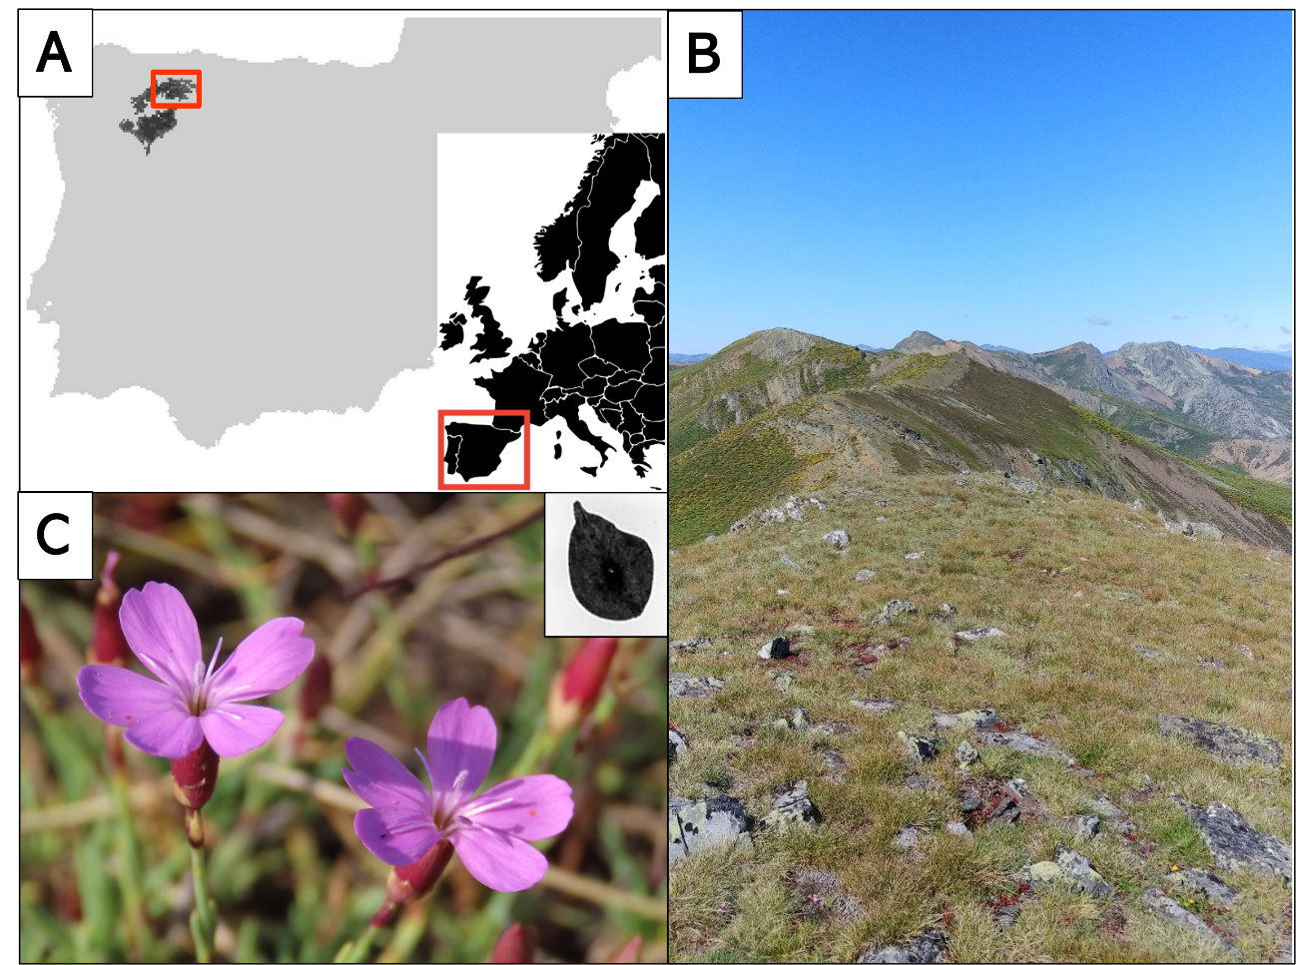

Fig 2. Upper panel: Location of the four summits included in our study. Lower panels: Spatial image of our sampling cross design in each of our four summits, at each square we registered botanical inventories and buried iButtons, coloured squares represents where *D. langeanus* was presents and seeds were collected.

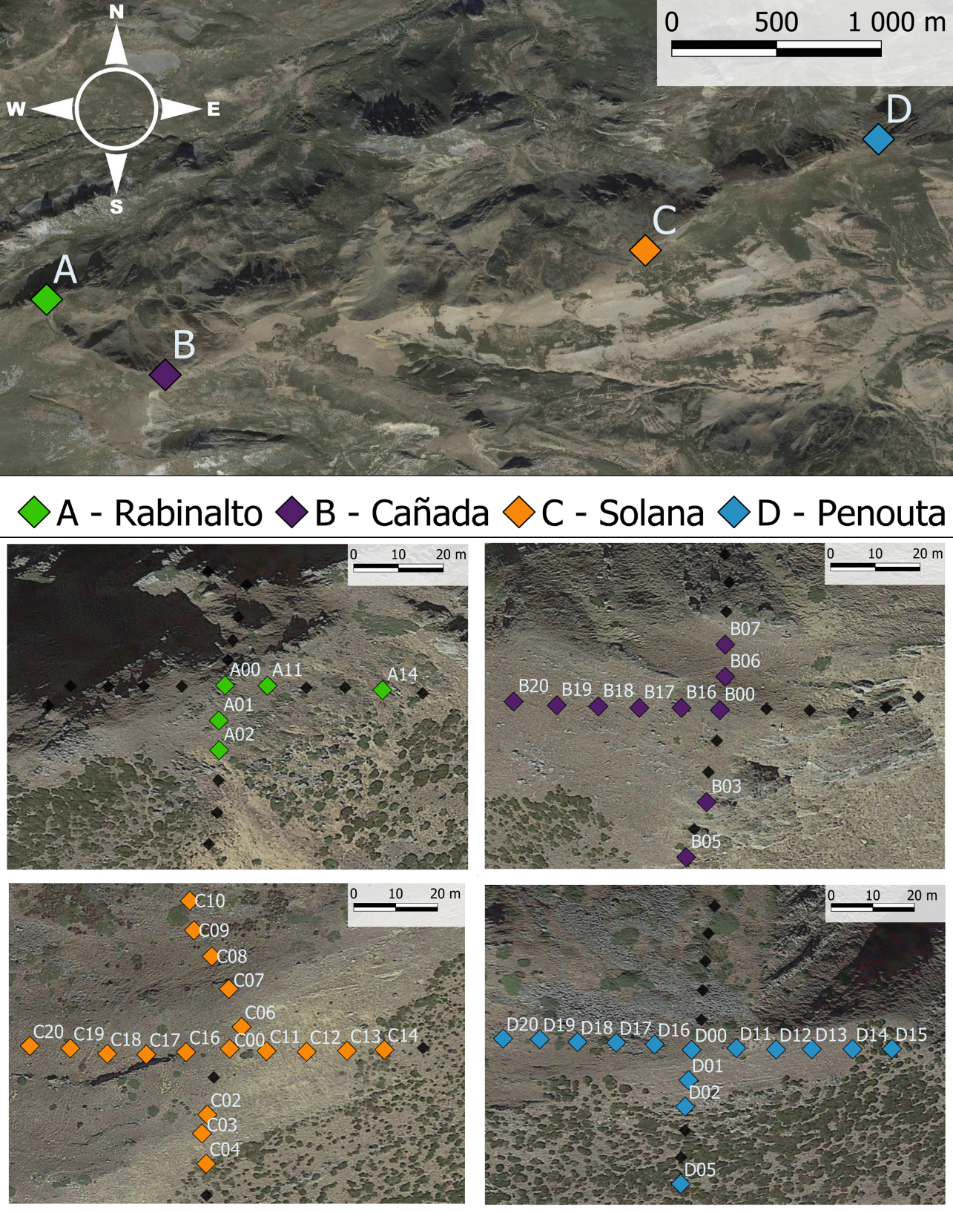

Fig 3. (A) Climogram of our study area, based on three of our summits Microlog SP3 data from July 2021 to June 2022. Lines in red represent monthly mean maximum and minimum temperatures; bars in grey represent the monthly mean of maximum ψb in Mpa. (B) Correlation graph between GDD and absolute sum of ψb registered. We used data from the growing season (April-November) of 2022 and 2023 in three of our summits, Cañada data is not complete and thus removed from visualization. (C) Principal Component Analysis of all 78 plots with environmental data, filtered according to iButtons recording specifications, each colour represents plots of a different summit.

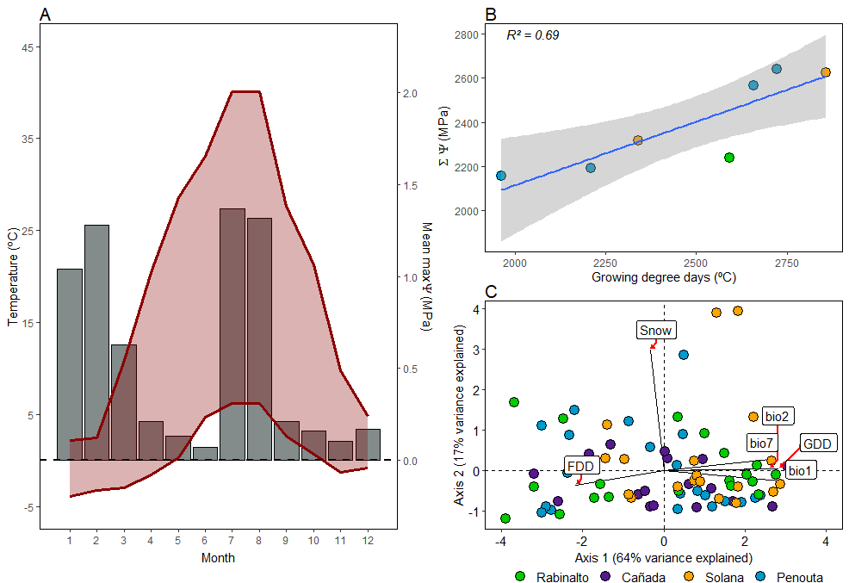

Fig 4. (A) Mean final germination proportion for both storage treatments in every water potential treatment (n subpopulations = 12 in both cases). Bottom panel (B): Cumulative germination curves from all subpopulations (N=12) for both storage treatments.

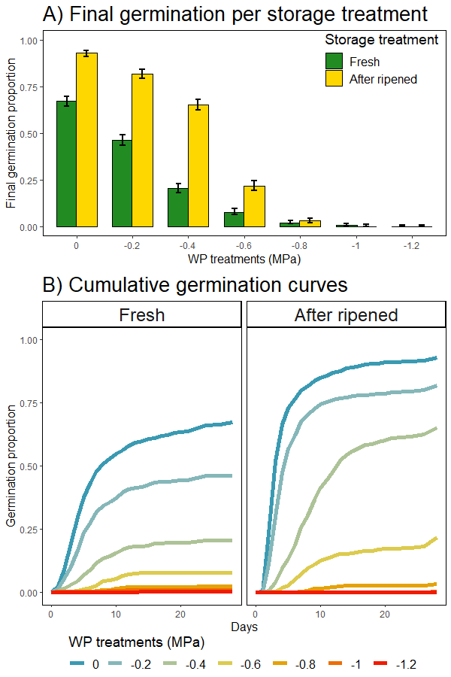

Fig 5. Base water potential calculated using seedr (Bradford method) for each subpopulation and their correlation with each subpopulation GDD. P-values from fitting a glmmTMB as explained in Methods.

